  BUSINESS NAME: CAPE WATERFRONT ESTATES Close Corporation  REGISTRATION NUMBER: CK94/11478/23  BUSINESS ADDRESS:  43 Victoria Avenue  Hout Bay  CAPE TOWN  7806  BUSINESS WEBSITE: www.capewaterfrontestates.co.za | 2026 MANUAL In terms of Section 51 of The Promotion to Access to Information Act 2/2000 (“the Act”)

Document title: | 2026 PAIA MANUAL | Revision date: | JUNE 2027
Responsible Dept: | COMPLIANCE: CAPE WATERFRONT ESTATES CLOSE CORPORATION | Version No.: | 2
Version compiled by: | MC COMPLIANCE CONSULTANTS | Version approved by:
Applicable to: | MANAGEMENT, PROFESSIONALS, ACCOUNTS AND ADMINISTRATION | Pages: | 30
Purpose | COMPLIANCE WITH THE PROMOTION OF ACCESS TO INFORMATION ACT 2 OF 2000
Last audited by: | MC COMPLIANCE CONSULTANTS | Level: | MANAGEMENT
Version Control | Approved | Detail
VERSION 1 |  | JUNE 2025
VERSION 2 |  | JUNE 2026

INDEX
1. | Background to and Purpose of the Promotion of Access to Information Act | 2
2. | Overview of the services offered by the agency | 4
3. | Communications Officer for the agency - Section 51(1)(a) | 4
4. | Information Officer of the agency | 5
5. | The Act and the Section 10 Guide | 8
6. | Request procedures and facilitation | 8
7. | Prescribed fees | 11
8. | Information available in terms of Legislation | 11
9. | Information automatically available | 15
10. | Information available in terms of the Act on Application | 15
11. | Information Requested about a Third Party | 17
12. | Sharing of Information Cross-Border | 18
13. | Direct Marketing | 18
14. | Cyber Security Measures | 19
15. | Updating of the Manual | 20
16. | Signatures | 20
 | Definitions and General terms Applicable in this Manual | 21
 | Addendum A: Form 2 | 23
 | Addendum B: Form 3 | 27
 | Addendum C: Fees | 29

- BACKGROUND TO AND PURPOSE OF THE PROMOTION OF ACCESS TO INFORMATION ACT

  - The Promotion of Access to Information Act, No 2 of 2000 (“the Act”) was enacted on 3 February 2000, giving effect to the rights created in terms of Section 32 of the Bill of Rights in the Constitution of the Republic of South Africa 108 of 1996 (the Constitution) of access to any information held by the state or any information that is held by another person or entity and that is required for the exercise or protection of any rights.

  - In terms of Section 51 of the Act, all Private Bodies are required to compile an Information Manual which also means that Cape Waterfront Estates Close Corporation (the agency) must comply.

  - This PAIA Manual is intended to ensure that the agency complies with the Act and to foster a culture of transparency and accountability within the agency by giving effect to the right to information.

  - Where a request is made in terms of the Act, the agency will be obliged to release the information, subject to applicable legislative or regulatory requirements except where the Act expressly provides that the information may or must not be released or where the agency has classified the information as proprietary or confidential.

  - The Act sets out the relevant procedures to be adopted when such an information request is received by the agency.

  - In order to promote effective governance in the agency, it is necessary to ensure that everyone who interacts with the agency is empowered and educated to understand their rights in terms of the Act in order for them to exercise their rights in relation to Public and Private bodies, including that of the agency.

  - This PAIA Manual is useful for the public to:

    - Check the categories of records held by the agency which are available without a person having to submit a formal PAIA request;

    - Have a sufficient understanding of how to make a request for access to a record of the agency by providing a description of the subjects on which the agency holds records, and the categories of records held on each subject;

    - Know the description of the records of the agency which are available in accordance with any other legislation;
    - Access all the relevant contact details of the Information Officer and Deputy Information Officer if applicable, who will assist the public with the records they intend to access;
    - Know the description of the guide on how to use PAIA, as updated by the Regulator and how to obtain access to it;

    - Know if the agency will process Personal and Special Personal Information, the purpose of processing of Personal and Special Personal Information and the description of the categories of Data Subjects and of the information or categories of information relating thereto;

    - Know the description of the categories of Data Subjects and of the information or categories of information relating thereto;

    - Know the recipients or categories of recipients to whom the Personal and Special Personal Information may be supplied;

    - Know if the agency has planned to transfer or process Personal and Special Personal Information outside the Republic of South Africa and the recipients or categories of recipients to whom the Personal and Special Personal Information may be supplied; and

    - Know whether the agency has appropriate security measures to ensure the confidentiality, integrity and availability of the Personal and Special Personal Information which is to be processed.

  - In addition, this PAIA Manual complies with the requirements set out in Section 10 of the Act and recognizes that, upon commencement of the Protection of Personal Information Act 4 of 2013 (“POPIA”), the appointed Information Regulator will be responsible to regulate compliance with the Act.

  - POPIA promotes the protection of Personal Information processed by a Private Body or Public Body, including certain conditions so as to establish minimum requirements for the Processing of Information.

  - POPIA amends certain provisions of PAIA, balancing the need for access to information against the need to ensure the protection of Personal Information, by providing for the establishment of an Information Regulator to exercise certain powers and perform certain duties and functions in terms of POPIA and PAIA, the issuing of codes of conduct, and the rights of persons regarding unsolicited electronic communications and automated decision making, to regulate the flow of Personal and Special Personal Information and to provide for matters concerned therewith.

  - In terms of POPIA, the agency may collect all types of Personal Information, including Special Personal Information, relating to an identifiable, living, natural person with whom it interacts, and where it is applicable, an identifiable, existing juristic person, including but not limited to:

    - name, address (including proof of address),
    - other contact details (including email addresses and telephone numbers),
    - gender,
    - marital status,
    - date and place of birth,
    - nationality,
    - employer,
    - job title,
    - financial records and employment history, and
    - family details, including their relationship to the Data Subject;
    - identification numbers issued by government bodies or agencies, such as the Data Subject's identity number, passport number, tax identification number, driving licence number, and company registration number;
    - information relevant to the provision of the agency’s services;
    - information relevant to the procurement of products and services from suppliers;
    - bank account or payment details,
    - information that the Data Subject provides to the agency as part of it providing its services to the Data Subject, which depends on the nature of the Data Subject's interactions with the agency;
    - information the Data Subject provides to the agency for the purposes of attending meetings and events;
    - still and video images captured by CCTV at any of the agency’s offices; and
    - identity data, contact data, and Special Personal Information from publicly available sources or third parties, service providers and the like, who conduct screening on any employee, client, or service providers for anti-money laundering purposes.

  - Examples of third parties from whom Personal Information may be collected include:

    - other property professionals;
    - connected parties in a transaction;
    - clients when the agency handles Personal Information on their behalf;
    - Regulatory Bodies;
    - companies providing services to the agency; and
    - where the agency makes use of publicly available sources of information.

  - Hereunder is a short summary of the categories of Data Subjects of the agency and the information or categories of information relating thereto that may be processed:

CATEGORY OF DATA SUBJECTS | PERSONAL INFORMATION WHICH IS COLLECTED AND PROCESSED
Clients | Name, gender, home address and telephone number, date of birth, biometric information, emergency contact details, copy of passport and national identification document, employer details and contact information, date of transaction, tax number, industry of trade, political association, banking details, VAT numbers and bank details, tax numbers, source of income, source of funds, source of wealth, residency, citizenship, property ownership, mortgage bond particulars.
Service Providers | Names, registration numbers or identify numbers, VAT numbers, addresses, trade secrets, BB-BEE status and bank details.
Employees and potential employees | Name, gender, telephone number, date of birth, photograph, biometric information, marital status, emergency contact details, ethnicity, residency and work permit status, nationality and passport information (including copies thereof), professional certifications and registrations, confirmation of qualifications, disability status and details where applicable and special needs, salary expectations, Covid-19 vaccination status may be monitored. Where permitted by law proportionate in view of the function to be carried out by an employee or prospective employee, the results of credit and criminal backgrounds and driving history. Tax number, social security number (country specific), banking details, sick pay, pensions, insurance and other benefit information, information about any spouse, minor children, or other eligible dependents and beneficiaries. Date of appointment, dates of promotion, work history, technical skills and educational background. Date of learning activities, duration, scores and learning completions. Date of resignation or termination, reason for resignation or termination, information relating to administering termination of employment Records of work absences, vacation entitlement and requests, salary history, performance appraisals, letters of appreciation and commendation, disciplinary and grievance procedures and psychometric assessment records. Where permitted by law and proportionate in view of the function to be carried out by an employee or prospective employee, the results of credit and criminal background checks, the results of drug and alcohol testing (country specific), screening, health certifications, drivers licence number, vehicle registration and driving history. Information required to comply with laws, the requests and directions of law enforcement authorities or court orders, Tax number, audit requirements (country specific).
Debtors/ Creditors | Names, addresses, registration numbers or identity numbers, statements, invoices, bank details.

- OVERVIEW OF THE SERVICES OFFERED BY THE AGENCY

  - The agency business operates as a duly registered Close Corporation, compliant with South African corporate legislation, in the Real Estate Industry and regulated by the PPRA with a valid Fidelity Fund Certificate.

  - The agency is also an established real estate business which facilitates residential property sales and property rentals for properties mostly, but not exclusively, situated in Atlantic Seaboard, Hout Bay, Llandudno and Constantia, Cape Town.

- COMMUNICATIONS OFFICER FOR THE AGENCY

NAME AND SURNAME | MARGIE ANN MACKENZIE
POSITION | MANAGING MEMBER
TELEPHONE NUMBER | +27 (0)21 790 7644
BUSINESS ADDRESS | 43 VICTORIA AVENUE, HOUT BAY, 7806
EMAIL ADDRESS | margie@capewaterfrontestates.co.za

- INFORMATION OFFICER OF THE AGENCY

NAME AND SURNAME | MARGIE ANN MACKENZIE
POSITION | MANAGING MEMBER
TELEPHONE NUMBER | +27 (0)21 790 7644
BUSINESS ADDRESS | 43 VICTORIA AVENUE, HOUT BAY, 7806
EMAIL ADDRESS | margie@capewaterfrontestates.co.za

THE GENERAL RESPONSIBILITIES OF THE AGENCY’S INFORMATION OFFICER INCLUDE THE FOLLOWING

  - To ensure that a compliance framework is developed, implemented, monitored and maintained;

  - To ensure that a personal information impact assessment is done to ensure that adequate measures and standards exist to comply with the conditions for the lawful processing of Personal Information;

  - That internal measures are developed together with adequate systems to process requests for information or access thereto;

  - That internal awareness sessions are conducted regarding the provisions of POPIA, Regulations made in terms of POPIA, codes of conduct, or information obtained from the Regulator;

  - That, upon request by any person, copies of the manual are provided to that person upon the payment of a fee to be determined by the Regulator from time to time;

  - To ensure that the Data Incident Response Policy is circulated to all employee and that data incidents are properly managed when they occur;

  - To encourage compliance by all employee with the conditions for the lawful processing of Personal Information;

  - To work with the Regulator in relation to investigations conducted pursuant to prior authorisation required to process certain information of POPIA in relation to the agency;

  - To ensure continuous data backups and test those backups regularly for data integrity and reliability;

  - To review policy rules regularly, document the results, and update the Policies as needed;

  - To continuously update information security policies and network diagrams;

  - To ensure that critical operational applications and data are secure by patching known vulnerabilities with the latest fixes or software updates; and

  - To perform continuous computer vulnerability assessments and audits.

ANNUAL FILING REQUIREMENTS
  - The Information Officer must annually, in terms of Section 32 of PAIA, submit to the Regulator a report regarding:

    - The number of requests for access received, the number of requests for access granted in full and the number of requests for access granted in terms of Section 46 of PAIA;

    - The number of requests for access refused in full and refused partially and the number of times each provision of PAIA was relied on to refuse access in full or partially;

    - The number of cases in which the periods stipulated in Section 25(1) of PAIA were extended in terms of Section 26 (1) of PAIA;

    - The number of internal appeals lodged with the relevant authority and the number of cases in which, as a result of an internal appeal, access was given to a record;

    - The number of internal appeals which were lodged on the ground that a request for access was regarded as having been refused in terms of Section 27 of PAIA;

    - The number of applications to a court which were lodged on the ground that an internal appeal was regarded as having been dismissed in terms of Section 77 (7) of PAIA.

  - The Regulator may, annually, request that the Information Officer of the agency, in terms of Section 83 (4) of PAIA, furnishes to the Regulator with information about requests for access to records of that body.

DELEGATION OF DUTIES TO THE DEPUTY INFORMATION OFFICER
  - An Information Officer(s) of both a Public or Privacy Body may, subject to legislation and policies governing the employment of personnel of the body concerned, delegate any power or duty conferred or imposed on him or her to a Deputy Information Officer of that body in terms of Section 56(b) of POPIA and Section 17(3) of PAIA;

  - Only an employee of the agency can be delegated as a Deputy Information Officer and at the time of this Manual, the agency had appointed the following Deputy Information Officer with the necessary delegation of powers:

NAME AND SURNAME | CLARE ELAINE PUTSMAN
POSITION | MEMBER
TELEPHONE NUMBER | +27 (0)21 790 7644
BUSINESS ADDRESS | 43 VICTORIA AVENUE, HOUT BAY, 7806
EMAIL | clare@capewaterfrontestates.co.za

  - The delegation referred to above must be in writing, using the template provided in the Information Regulator’s Guideline – InfoRegSA-GuidanceNote-IO-DIO-20210401.pdf;

  - The delegation of any powers or duties and responsibilities to a Deputy Information Officer will not prohibit an Information Officer from exercising the powers or performing the duty that he or she has delegated to a Deputy Information Officer;

  - Any power, duties and responsibilities delegated to a Deputy Information Officer should be exercised or performed subject to such conditions as an Information Officer may consider necessary;

  - Any conditions of delegation, as conferred on the Deputy Information Officer, should ensure that the agency is as accessible as reasonably possible for Data Subjects or Requestors;

  - The Information Officer of the agency must ensure that he reserves his rights in the aforesaid delegation to exercise the powers or to perform the duties and responsibilities concerned and withdraw or amend the aforesaid delegation at any time;

  - The Information Officer must be aware that any right or privilege acquired, or any obligation or liability incurred because of a delegation of any powers, duties and responsibilities is not affected by any subsequent withdrawal or amendment of the decision to delegate;

  - Depending on the circumstances of the case, the obligation or liability incurred because of any delegation of any powers, duties and responsibilities may be imposed on either the Information Officer or the agency in so far as POPIA is concerned in line with Section 17(6)(b) of PAIA;

  - To ensure a level of accountability by the delegated Deputy Information Officer, the agency is encouraged to ensure that such duties and responsibilities or any power delegated to a Deputy Information Officer are part of their job description;

  - Despite the above-mentioned delegation to the Deputy Information Officer, the Information Officer retains the accountability and responsibility for the functions delegated to the Deputy Information Officer.

THE DATA BREACH RESPONSIBILITIES OF THE AGENCY’S INFORMATION OFFICER INCLUDE THE FOLLOWING:

  - Ascertaining whether personal data was breached;
  - Assessing the scope and impact by referring to the following:
    - Estimated number of Data Subjects whose personal data was possibly breached;

    - Determining the possible types of personal data that were breached; and

    - Listing the security measures that were already in place to prevent the breach from happening.

  - Once the risk of the breach is determined, the following parties need to be notified within 72 hours after being discovered:
    - The Information Regulator;

    - Any Data Subject of the agency who may require notification;

    - Communication should include the following:

      - Contact details of Information Officer;

      - Details of the breach;

      - Likely impact;

      - Actions already in place, and those being initiated to minimise the impact of the data breach; and

      - Any further impact is being investigated (if required), and necessary actions to mitigate the impact are being taken.

REVIEW AND MONITOR
  - Once the data breach has been contained, the agency will conduct a review of existing measures in place and explore the possible ways in which these measures can be strengthened to prevent a similar breach from reoccurring.
  - All such identified measures should be monitored to ensure that the measures are satisfactorily implemented.
- THE ACT AND SECTION 10 GUIDE

  - The South African Human Rights Commission has compiled the Guide as required in terms of Section 10 of the Act.

  - Any Requestors are referred to the Guide in terms of Section 10 which will contain information for the purposes of exercising their Constitutional Rights. The Guide is available from the SAHRC.

  - An official PAIA Guide has been compiled which contains information to assist a person wishing to exercise a right of access to information in terms of PAIA and POPIA. Copies of the PAIA Guides are available, in two official languages, English and Afrikaans for public inspection at our registered head office during normal business hours (08h30 – 16h30).

  - The contact details of the Commission are:

THE SOUTH AFRICAN HUMAN RIGHTS COMMISSION
at PAIA Unit (THE RESEARCH AND DOUMENTATION DEPARTMENT)
Postal Address: Private Bag 2700, Houghton, 2041
Telephone Number: +27 11 877 3600
Telephone Number: +27 11 484 8300
Facsimile Number: +27 11 484 1360
Fax Number: +27 11 403 0625
Website: www.sahrc.org.za

  - The PAIA Guide is also available on the Regulator’s website https://inforegulator.org.za/paia-guidelines/, in all eleven (11) official languages and copies thereof, including braille, are available at the Office of the Information Regulator, for inspection, during normal office hours.

  - The Information Regulator can be reached at:

THE INFORMATION REGULATOR  POSTAL ADDRESS  PHYSICAL ADDRESS  TELEPHONE NUMBER  E-MAIL ADDRESS | P O Box 31533, Braamfontein, Johannesburg, 2017  Woodmead North Office Park, 54 Maxwell Drive, Woodmead, Johannesburg  +27 (0) 101 023 5200  enquiries@inforegulator.org.za
INFORMATION OFFICER  TELEPHONE NUMBER  E-MAIL ADDRESS | Mr. Mosalanyane Mosala  +27 (0) 10 023 5251  MMosala@inforegulator.org.za
DEPUTY INFORMATION OFFICER  TELEPHONE NUMBER  E-MAIL ADDRESS | Mr. Jaco Jansen  +27 (0) 10 023 5237  JJJansen@inforegulator.org.za

  - Requests in terms of the Act shall be made in accordance with the prescribed procedures, at the rates provided. The forms and tariffs are dealt with in clauses 6 and 7 below.

- REQUEST PROCEDURES AND FACILITATION

  - Procedural requirements:

    - The Requestor must comply with all the procedural requirements contained in the Act relating to the request for access to a record.

    - The Requestor must complete the prescribed form enclosed hereto – ADDENDUM A: FORM 2 and submit same as well as payment of the required fee/s and a deposit if applicable to the Information Officer at the postal or physical address, fax number or electronic mail address as noted in clause 5 above.

    - The prescribed form must be completed with sufficient information to enable the Information Officer to identify:

      - The record/records requested;

      - The identity of the Requestor;

      - The rights based on which the Requestor is requesting the information or copies of documents;

      - Which form of access is required and supply the postal or physical address to which the information or copies are to be sent and/or the fax number or electronic mail address of the Requestor;

    - The agency will be obliged to process the request within a period of 30 (thirty) business days from the date of receipt of the request unless the Requestor has stated special reasons acceptable to the Information Officer for the information to be delivered sooner;

    - The required fees must be paid before any further processing can take place;

    - The Information Officer’s response may be delayed if it is found that information required from the Requestor is outstanding on the request and will remain delayed until the required information is provided.

    - The prescribed time periods will not commence until the Requestor has furnished all the necessary and required information.
  - Refusal of Access to Records

    - Section 9 of the Act recognizes that the right to access information cannot be unlimited and should be subject to justifiable limitations, including but not only:

      - Limitations aimed at the reasonable protection of privacy (refer the POPIA Data Privacy Policy available at the Hout Bay office of the agency or from the Information Officer – margie@capewaterfrontestates.co.za

      - Commercial confidentiality;

      - Where the disclosure would be likely to prejudice or impair:

        - the security of a building, structure, or system, including, but not limited to, a computer or communication system; a means of transport or any other property, methods, systems, plans, or procedures for the protection of an individual, in accordance with a witness protection scheme, the safety of the public, or any part of the public and the security of property contemplated in subparagraph (i) (aa), (bb) or (cc) of section 66(b) of PAIA;

        - the record contains trade secrets of the agency, contains financial, commercial, scientific, or technical information, other than trade secrets, the disclosure of which would be likely to cause harm to the commercial or financial interests of the agency;

        - the record contains information, the disclosure of which could reasonably be expected to put the agency at a disadvantage in contractual or other negotiations;

        - the record may prejudice the agency in commercial competition or be a computer program, as defined in section 1(1) of the Copyright Act, No. 98 of 1978, owned by the agency, except insofar as it is required to give access to a record to which access is granted in terms of PAIA; or

        - the record contains information about research being or to be carried out by or on behalf of the agency, the disclosure of which would be likely to expose the agency, a person that is or will be carrying out the research of behalf of the agency or the subject matter of the research, to serious disadvantage. and

    - Effective and efficient governance and in a manner which balances that right with other rights and in a manner which balances that right with any other rights, including such rights contained in the Bill of Rights in the Constitution.

    - The main grounds therefore on which the agency may refuse a request for information relate to:

      - The mandatory protection of privacy of a third party who is a natural or deceased person, or a juristic person as precluded by the POPIA;

      - The mandatory protection of the commercial information of a third party if the records contain trade secrets, financial/commercial/scientific or technical information which may cause harm to such third party if disclosed;

      - The mandatory protection of confidential information it if is protected in terms of an agreement;

      - The mandatory protection of records which would be regarded as privileged in legal proceedings;

      - The commercial activities of the agency;

      - Client information of the agency;

      - Financial and client information where harm may be caused to the agency;

      - Information which, if disclosed, may put the agency at a disadvantage;

      - Any software or hardware or any computer program to which the agency has copyright;

      - Requests which are clearly frivolous or vexatious, and which divert from usual resources.

    - Each request for information will be assessed by the agency’ Information Officer on its own merits and in accordance with reasonable and applicable legal principles.

  - Lost records

    - If a requested record cannot be found or if the record does not exist, the Information Officer shall make an affidavit or other acceptable declaration to such effect notifying the Requestor that it is not possible to give access to the request.

  - Timelines applicable to requests

    - Requests for access by a Requestor will be processed within 30 days, unless the request contains considerations that are of such a nature that an extension of the 30-day time limit is necessary.

    - Such considerations include:

      - where the request is for many records or requires a search through many records (including where records that have been archived electronically need to be restored);

      - where the request requires a search for records in or the collection of such records from, an office of the agency located far away from its head office;

      - consultation within the agency or with another Private Body is necessary or desirable to decide upon a request that cannot reasonably be completed within the original 30-day period;

      - more than one of the circumstances contemplated in paragraphs 6.4.2.1, 6.4.2.2, 6.4.2.3 exist in respect of the request making compliance with the original period not reasonably possible; or

      - the Requestor Consents in writing to such extension.

    - The Information Officer shall advise the Requestor whether access is granted or denied in respect of the request and such notice shall be in writing.

    - Unless the Requestor requests reasons for a decision, the Information Officer shall not be obliged to supply such reasons.

    - The above request should be made by the Requestor him/herself but in the event that the request is made on behalf of someone else, then proof of the authorization must accompany the initial request to the Information Officer.

    - If an extension is necessary, the Requester will be notified with reasons for the extension. If the Information Officer fails to communicate a decision on a request, such a request is then deemed to have been refused.

- PRESCRIBED FEES

  - The Act refers to two types of fees, namely the request fee which is a form of administration fee payable by all Requestors except personal Requestors and the access fee which is payable by all Requestors in the event that the request is granted.

  - The access fee includes the costs of obtaining and preparing a record for delivery to the Requestor.

  - A summary of all PAIA fees is set out in the ADDENDUM C: Fees and ADDENDUM B: FORM 3 which is also available from the SAHRC’s website at www.sahrc.org.za.

  - The following applies to requests (other than personal requests):

    - A requestor is required to pay the prescribed request fees (R50.00, as specified by the SAHRC) before a request will be processed;
    - If the preparation of the record requested requires more than the prescribed hours (six), a deposit shall be paid (of not more than one third of the access fee which would be payable if the request were granted);
    - A requestor may lodge an application with a court against the tender/payment of the request fee and/or deposit;
    - Records may be withheld until the fees have been paid.

  - If the search for the record has been made and the preparation of the record for disclosure together with arrangements to make the record available, requires more than the hours prescribed in the regulations for this purpose, the Information Officer shall notify the Requestor to pay, as a deposit, the prescribed portion of the fee.

  - If a request is declined, any deposit paid by the Requestor must be refunded to such Requestor.

- INFORMATION AVAILABLE IN TERMS OF LEGISLATION
  - Records of a public nature, typically those published on the website of the agency, may be accessed without the need for a formal application.
  - Other public records, such as records of CIPC may also be accessed without the need for a formal application, although an appointment will have to be secured with the Information Officer in order to view such records
  - The following categories of records are held by the agency, and access may be granted to such records upon proper request unless the agency is entitled to refuse access to such records, or the records are exempted in terms of PAIA:

CATEGORY | Information category description
PROPERTY PRACTITIONERS ACT 22 OF 2019 | Regulatory requirements to operate as a Property Practitioner  Any person (natural or legal) who in the ordinary course of business, for gain (i.e. against payment), holds out (i.e. this is his/her business), on behalf of another person:  auctions; rents; sells or exhibits for sale or purchase, property or a business;  manages property;  negotiates such an agreement;  canvasses for landlords/tenants/buyers or sellers of properties/businesses; or  collects or receives rental on behalf of another person;  acts as intermediary or facilitator in any of the above (neither are defined in the act but a google definition provides the following):  intermediary – a person who acts as a link between people in order to try and bring about an agreement;  facilitator: any activity that makes a social process easy or easier.  It also includes a Homeowners Association which does any of the above, for gain; and  anyone employed by a property practitioner to do any of these things on his / her behalf; and  includes anyone who sells, or markets time share or fractional ownership and includes  anyone who is employed to manage / supervise the day-to-day business operations of a property practitioner (office manager); and also  anyone who arranges:  financing for a sale or lease;  bridging finance (i.e. where a seller wants to take an advance against the proceeds of his sale) or;  acts as a bond broker, (someone who helps a buyer apply for a loan with the banks)  except if either of these, fall within the definition of a “financial institution” under the Financial Services Board Act.  It includes directors of companies; members of CC’s and trustees of trusts, if the entity does any of the above; and also,  any attorney or person employed by an attorney who renders these services except if that person must hold an FFC with the Attorneys’ Fidelity Fund, and if this work forms part of the attorney’s normal practice.  Anyone may apply to the Minister for exemption (partially or entirely from the Act) for up to 3 years at a time
FINANCIAL INTELLIGENCE CENTRE ACT, NO 38 OF 2001 | Identification and verification records  Client due diligence records  Risk Management and Compliance Program  Training records  Records of transactions conducted on behalf of clients, including details of the transaction, parties involved, and purpose of the transaction.  Suspicious Activity / Transaction Reports (SARs / STRs)  Cash Threshold reports (CTRs)  Risk Assessments  Compliance procedures  Records of client details and transactions
BASIC CONDITIONS OF EMPLOYMENT ACT, NO 75 OF 1997 | Employee details  Workforce reports  Information on disability, race and religion  Employee next of kin or emergency contact details  Conflict of Interest declarations  Education Information  Health and safety records  Pension and provident fund records  Leave records  Internal evaluations and performance records  Disciplinary records  Training records  Background checks
BROAD-BASED BLACK ECONOMIC EMPOWERMENT ACT, NO. 53 OF 2003 | Skills development section on the Financial Services Council report  BBBEE status  BBBEE status of suppliers  Supplier employee information  Contractor and supplier agreements  List of suppliers and services
COMPENSATION FOR OCCUPATIONAL INJURIES AND DISEASES ACT, NO. 130 OF 1993 | Records of employee’ earnings and particulars
CONSUMER PROTECTION ACT, NO. 68 OF 2008 | Records of consumer transactions and contracts  Complaint resolution records  Promotional-competition-related records
ELECTRONIC COMMUNICATIONS AND TRANSACTIONS ACT, NO. 25 OF 2002 | Electronic transaction records  Records of Electronic communications with clients or partners
EMPLOYMENT EQUITY ACT, NO. 55 OF 1998 | Employment Equity Plans and records  Records of employment equity assessments and targets  Recruitment and promotion records
INCOME TAX ACT, NO 58 OF 1962 | Tax returns and filings  Records of income, expenses and deductions  Tax compliance certificates and correspondence
LABOUR RELATIONS ACT, NO. 66 OF 1995 | Disciplinary records and outcomes  Labour relations reports  Arbitration awards
OCCUPATIONAL HEALTH AND SAFETY ACT, NO. 85 OF 1993 | Occupational Health and Safety Agreement and appointment letters  Incident reports  Personal information for workmen’s compensation  Personal information of visitors  CCTV Footage
PREVENTION AND COMBATTING OF CORRUPT ACTIVITIES ACT, NO. 12 OF 2004 | Anti-Bribery and Corruption Policy  Whistleblowing Policy  Gift Policy
SKILLS DEVELOPMENT ACT, NO. 97 OF 1998 | Sector Education and training authority reports  Learning history reports  Skills development levies  Certificates of Completion
UNEMPLOYMENT INSURANCE CONTRIBUTIONS ACT, NO. 4 OF 2002 AND UNEMPLOYMENT INSURANCE ACT, NO. 30 OF 1996 | Tax invoices, credit notes, debit notes  Bank statements, deposit slips  Employee details and employment contracts  Employer registration and contribution records  UIF claims records  Audit and inspection records
VALUE ADDED TAX ACT, NO. 89 OF 1991 | VAT registration documents  Tax invoices and credit notes  VAT returns and filings  VAT payment records  VAT exemption certifications  Input VAT documentation  Records for cross-border transactions  VAT compliance records
COMPANIES ACT, NO. 71 OF 2008 | Company registration records  Corporate governance documents  Engagement letters  Meeting minutes  Correspondence of enquiries from customers

- INFORMATION AUTOMATICALLY AVAILABLE

  - The following records are automatically available to all employees of the agency and need not be requested in accordance with the procedure outlined in clause 6:

    - Personnel records particular to the employee whose file it is;
    - Records of disciplinary hearings and related matters are available to the employee concerned;
    - The agency’s Policies and procedures manuals.

  - The following records are automatically available to the general public and all employees and need not be requested in accordance with the procedure outlined in clause 6:

    - Information on the agency’s website: www.capewaterfrontestates.co.za;
    - Advertising and marketing materials which have been published in the public domain;
    - Public listings;
    - Newsletters and circulars which have been circulated publicly;
    - Overview of Services;
    - Careers Portal;
    - Modern Slavery Statement;
    - Website Terms of Use;
    - Privacy Statement;
    - Contact Details;
    - Policies related to Business Conduct and Ethics;
    - Anti-Bribery Policy;
    - Ethics Contact Persons.

- INFORMATION AVAILABLE IN TERMS OF THE ACT ON APPLICATION

  - Requestors are not automatically allowed access to records listed as proprietary or confidential hereunder and access to them may be refused by the agency in accordance with Sections 62 to 69 of The Act.

  - A request is subject to Section 63(1) of the Act, which provides that the agency may refuse a request for access to a record in possession of the agency if the disclosure of the record would involve the unreasonable disclosure of Personal and Special Personal Information about a third party including a deceased individual or if the information is confidential or proprietary:

TYPE OF RECORDS | DETAILED EXAMPLES | CLASSIFICATION
BUSINESS ACCOUNTING RECORDS | - Annual financial statements and working papers  - General ledger  - Bank statements, cheque books, cheques  - Client and supplier statements and invoices  - Deposit slips  - Cash books and petty cash books  - Fixed asset register  - Tax returns and assessments  - VAT returns  - Lease or instalment sale agreements  - Budgets and business plans  - Insurance records  - Auditor's reports  - Internal auditors' reports  - Compiler's reports  - Accounting officer's reports  - Reviewer's reports  - Inventory records (including stock take)  - Systems documentation  - Management reviews  - Capital expenditure  - Record of assets  - Record of liabilities  - Record of loans to related parties  - Record of liabilities and obligations  - Record of property held  - Record of revenue  - Record of expenses | PROPRIETARY
CREDIT AGREEMENTS | - Credit Provider's documents | PROPRIETARY
FIXED PROPERTY | - Leases  - Mortgage bonds or other encumbrances  - Title deeds | PROPRIETARY
HEALTH AND SAFETY | - Evacuation Report  - Minutes of safety committee meetings (if any) | CONFIDENTIAL
INFORMATION TECHNOLOGY AND SYSTEMS | - Hardware  - Internet  - Software packages  - Telephone exchange equipment  - Telephone lines, leased lines and data lines | PROPRIETARY
PROFESSIONAL AND OTHER INSURANCE | - Claim records  - Details of coverage, limits and insurers  - Insurance policies | PROPRIETARY
LEGAL AGREEMENTS | - Contracts with Clients  - Contracts with Employees  - Contracts with External Service Providers  - Contracts with Suppliers with shareholders, officers or members | CONFIDENTIAL
PERSONELL RECORDS (HUMAN RESOURCES) | - Disciplinary records  - Employee information records  - Employee loans  - Employee remuneration  - Employment applications  - Employee date of birth  - Employment contracts  - IRP 5 and IT 3 certificates  - Letters of appointment  - Leave applications  - Maternity leave policy  - Payroll  - Particulars of each employee  - Personnel files  - Recruitment and appointments  - Salary and wage registers  - Salary slips and wage records  - Tax returns of employee  - Training and development  - UIF, PAYE and SDL returns  - Workmen's Compensation documents | CONFIDENTIAL
MARKETING | - Newsletters  - Service information  - Client onboarding details  - Marketing agreements  - Debt Acknowledgement  - Invoices, Credit notes, C-notes | PROPRIETARY
INTELLECTUAL PROPERTY | - Templates  - Digital and physical publications  - Internal and External Compliance Policies | CONFIDENTIAL
STATURORY COMPANY RECORDS | - Annual Statutory Returns  - Certificate of Change of Name  - Certificate of Incorporation  - Certificate to Commence Business  - Dividend register  - Members' attendance register  - Memorandum and Articles of Association  - Notice and minutes of shareholders' meetings  - Minutes of members' meetings  - Proxy documents  - Resolutions  - Shareholders' agreements  - Shareholders' register | PROPRIETARY
TAX | - Income tax returns  - Provisional tax returns  - Tax assessments  - VAT documents | PROPRIETARY
THIRD PARTIES | - Section 71 of PAIA makes provision for a request for information or records about a third party.  - In considering such a request, the agency will adhere to the provisions of Sections 71 to 74 of the Act.  - In certain circumstances, the agency will be obliged to advise third parties of requests lodged in respect of information applicable to or concerning such third parties.  - In addition, the provisions of Chapter 2 of Part 4 of PAIA entitle third parties to dispute the decisions of the head of the agency or the Information Officer by referring the matter to the High Court. | CONFIDENTIAL

- INFORMATION REQUESTED ABOUT A THIRD PARTY

  - Section 71 of the Act makes provision for a request for information or records about a third party.

  - In considering such a request, the agency will adhere to the provisions of Sections 71 to 74 of the Act.

  - The attention of the Requestor is drawn to the provisions of Chapter 5 of Part 3 of the Act in terms of which the agency is obliged, in certain circumstances, to advise third parties of requests lodged in respect of information applicable to or concerning such third parties.

  - In addition, the provisions of Chapter 2 of Part 4 of the Act entitles third parties to dispute the decisions of the agency by referring the matter to the High Court.

- SHARING OF INFORMATION CROSS-BORDER

  - Internationals and South African data protection laws generally agree that anyone processing personal data may only transfer it to someone outside of the country under certain circumstances.

  - The General Data Protection Regulation (GDPR) is a legal framework that sets guidelines for the collection and processing of personal information from individuals who live in and outside of the European Union (EU).

  - Bearing in mind that POPIA is largely based on the GDPR and that POPIA prescribes that processing conditions should be established ‘in harmony with international standards’, some reliance can be placed on those countries which the European Commission has declared as having such adequate safeguards.

  - POPIA recognises the need to transfer personal information from South Africa and states that its purpose is to protect ‘important interests, including the free flow of information within the Republic and across international borders’.

  - Section 72 of POPIA deals with transfers of personal information outside South Africa or transborder information flows. It essentially says that the agency may not transfer personal information about a data subject to a third party who is in a foreign country unless certain protections are in place, such as:

    - Adequate legal protection: The recipient of the personal information must be subject to a law, binding corporate rules or binding agreement which provide an adequate level of protection that effectively upholds the principles for reasonable processing, and that include provisions that are substantially similar to the conditions for the lawful processing of personal information and for the further transfer of personal information;

    - Consent: The data subject consents to the transfer;

    - Necessary for the performance of a contract: The transfer is necessary for the performance of a contract between the data subject and the responsible party, or for the implementation of pre-contractual measures taken in response to the data subject’s request;

    - Interests of the data subject: The transfer is necessary for the conclusion or performance of a contract concluded in the interest of the data subject between the responsible party and a third party; and

    - Benefit of the data subject: The transfer is for the benefit of the data subject in circumstances where it is not reasonably practicable to obtain the consent of the data subject for the transfer, and the data subject would be likely to give consent had it been obtained.

- DIRECT MARKETING
  - The agency does not share data subjects’ information with third-parties for the sole purpose of using the information for direct marketing.
  - South Africa’s direct marketing landscape changed significantly in April 2026 when the Consumer Protection Act 68 of 2008 (“CPA”) Amendment Regulations (the Regulations) came into effect. The most important development is that the National Consumer Commission (NCC) established an opt-out registry that requires registration by direct marketers and allows consumers to block unwanted marketing communications before they even arrive.
  - For businesses engaged in direct marketing, this means complying with new registration requirements with the NCC and ongoing payment and compliance obligations.
  - The CPA’s direct marketing rules apply when the agency directly markets our services to individual consumers or to small juristic businesses with annual turnover or assets below R2,000,000.00. When the agency markets to large corporates exceeding this threshold, the new direct marketing rules will fall outside the CPA’s scope.
  - The agency acknowledges that it is prohibited under the CPA to contact any consumer who has previously opted out of receiving direct marketing directly with the agency.
  - The new pre-emptive block will allow the agency’s consumers to register their preference before any marketing contact occurs.
  - The opt-out registry will be operated through the NCC’s eServices platform. Registration is expected to open in July 2026, with the system anticipated to be fully operational by September 2026. The registry will allow consumers to register a block to prevent any unwanted electronic communication from direct marketers.
  - To register a pre-emptive block, consumers must complete a form on the NCC’s eServices platform - NCC eservice which requires personal details including identity or passport number, full names, physical address, and contact information. Consumers must provide accurate information and ensure their details on the opt-out registry remain up to date.
  - Once a consumer has registered a pre-emptive block, the agency will be prohibited from directly marketing its services to that consumer. The Regulations impose strict obligations on the agency as direct marketers and the agency must remove a consumer from databases who have registered a pre-emptive block by cleansing such data monthly with the NCC for a fee.
  - In any event the agency will not be allowed to contact any consumer for direct marketing purposes unless registered as a direct marketer on the opt-out registry.
  - The agency will always ensure that the required direct marketing options are available to the agency’s data subjects, and which will allow the recipients to request a removal of their details from these bulk emails are clearly implemented.
  - The agency may utilise the Personal Information of an existing client of the agency for the purposes of providing the client with information regarding services that may be of interest to the client.
  - If a new client has not registered the pre-emptive block referred to above, such client must still be given an opportunity to object to receiving direct marketing material by electronic communication at the time that their personal information was collected.
  - The agency may approach a person to ask for their consent to receive direct marketing material only once, and the agency may not do so if it the client has previously refused their consent or registered their pre-emptive block.
  - Should the agency receive consent to send direct electronic marketing to a non-client of the agency, such direct electronic marketing material must have an opt-out option.
- CYBER SECURITY MEASURES
 | COMPANY DETAILS | CONTACT DETAILS | CONTACT PERSON
INTERNET CONNECTION SUPPORT/ HOSTS | OPEN SERVE (TELKOM) | 10214 | ONLINE REPORTING
SOCIAL MEDIA PAGES | GABRIELLA LUPINI (CWE) | 078 223 1091 | N/A
CRM (CLIENT DATA BASE) HOSTS | VIRTUAL AGENT / TPN | 0860 882000 / 0861 876000 | N/A
GENERAL IT (IN THE OFFICE) | JANE DE KOCK (CWE) | 076 676 6630 | N/A
EMAIL MANAGEMENT | XNEELO VIA WEBBOX | 021 460 0456 | GILLIAN
WEBSITE HOST | WEBBOX | 021 460 0456 | GILLIAN
CYBER SECURITY | BARRY (IT CWE) | 079 876 1703 | N/A
MARKETING | Clare Putsman (CWE) | 083 252 2485

TYPE OF CYBER SECURITY MEASURES | SUMMARY OF MEASURES | WHO CONTROLS THE UPDATING | HAS A CYBER AUDIT BEEN DONE | HAVE CYBER INCIDENTS BEEN PICKED UP
FIREWALL | BARRY (IT CWE) | BARRY (IT CWE) | YES | NO
ANTI VIRUS | BARRY (IT CWE) | BARRY (IT CWE) | YES | NO
DOUBLE AUTHENTICATION | SELF I.E AGENT DEVICES | BARRY (IT CWE) | YES | NO
DEVICES PRIVACY SETTINGS ACTIVATED | SELF I.E AGENT DEVICES | BARRY (IT CWE) | YES | NO
EMAIL BACK UPS | XNEELO VIA WEBBOX | SUPPORT | N/A | XNEELO
SYSTEM BACK UPS | WEBBOX | SUPPORT | N/A | XNEELO
SSL ENCRYPTION | WEBBOX |  | NO | NO
PASSWORD MANAGEMENT | INDIVIDUAL MANAGEMENT (CWE) | EACH PERSON | NO | NO
SOFTWARE UPDATES | BARRY (IT CWE) |  | YES | NO

- UPDATING OF THE MANUAL

  - The agency may update this Manual annually or at such intervals as may be necessary.

  - This document does not purport to be exhaustive of or comprehensively deal with every procedure provided for in the Act. A Requestor is advised to familiarise his/her/itself with the provisions of the Act before lodging any request with the agency.

- SIGNATURES
This PAIA Manual of the agency is approved and signed by the Information Officer:
DATED ON:

SIGNED AT:

INFORMATION OFFICER:

DEFINITIONS AND GENERAL TERMS APPLICABLE IN THIS MANUAL
- In this document, clause headings are for convenience and shall not be used in its interpretation unless the context clearly indicates a contrary intention –
  - an expression which denotes
  - any gender includes the other genders;
  - a natural person includes an artificial or juristic person and vice versa;
  - the singular includes the plural and vice versa;
  - the following expressions shall bear the meanings assigned to them below and cognate expressions bear corresponding meanings –
  - "this document" - this document together with all of its annexures, as amended from time to time;
  - "the Act" - Promotion of Access to Information Act No. 2 of 2000 and any reference to any statute, regulation or other legislation shall be a reference to that statute, regulation or other legislation as at the signature date, and as amended or substituted from time to time;
- If any provision in a definition is a substantive provision conferring a right or imposing an obligation on any party then, notwithstanding that it is only in a definition, effect shall be given to that provision as if it were a substantive provision in the body of this document;
- Where any term is defined within a particular clause other than this, that term shall bear the meaning ascribed to it in that clause wherever it is used in this document;
- Where any number of days is to be calculated from a particular day, such number shall be calculated as excluding such particular day and commencing on the next day. If the last day of such number so calculated falls on a day which is not a business day, the last day shall be deemed to be the next succeeding day which is a business day;
- The use of the word "including" followed by a specific example/s shall not be construed as limiting the meaning of the general wording preceding it and the eiusdem generis rule shall not be applied in the interpretation of such general wording or such specific example/s;
- Insofar as there is a conflict in the interpretation of or application of this document and the Act, the Act shall prevail;
- Complaint means-
  - A matter reported to the Information Regulator in terms of Section 74(1) and (2) of the Act;
  - A complaint referred to in Section 76(1)(e) and 92(1) of the Act; and
  - A matter reported or referred to the Information Regulator in terms of other legislation that regulates the mandate of the Information Regulator;
- Day means a calendar day, unless the last day of a specified period happens to fall on a Sunday or on any public holiday, in which case the time shall be calculated exclusive of that Sunday or public holiday in accordance with Section 4 of the Interpretation Act, 1957 (Act No. 33 of 1957);
- Employee: shall mean any person who is employed by the agency.
- Office hours-
  - In respect of offices of the Information Regulator, means the hours between 08:00 and 16:00 on Monday to Friday, excluding public holidays; and
  - In respect of offices designated by the Information Regulator, means the hours during which the offices are operating;
- Relevant body/bodies: will refer to any specified body or class of bodies, or any specified industry, profession, or vocation or class of industries, professions, or vocations that in the opinion of the Regulator which has sufficient representation
- PAIA gives a Requestor the right to lodge a request for information with the Information Officer of a Private Body;
- POPIA: means the Protection of Personal Information Act 4 of 2013 together with any amendments and Regulations thereto;
- A Private Body, which includes the agency, Cape Waterfront Estates Close Corporation is defined as follows in PAIA:
  - a natural person who carries or has carried on any trade, business or profession, but only in such capacity;
  - a Partnership which carries or has carried on any trade, business or profession; or
  - any former or existing juristic person.

- PAIA defines the head of a Private Body as: “the chief executive officer or equivalent officer of the juristic person or any person duly authorized by that office….”
- A Requestor means:
  - any person, including, but not limited to, a Private or Public Body or an official thereof, making a request for access to a record of that private body; or
  - a person acting on behalf of the person contemplated in clauses 16.1.

- The agency: means:

BUSINESS NAME | CAPE WATERFRONT ESTATES CLOSE CORPORATION
REGISTRATION NUMBER | CK 94/11478/23
OFFICE ADDRESS | 43 VICTORIA AVENUE, HOUT BAY,7806

with all employees and agents involved in the agency, whether permanent or temporary, as far their obligations are concerned and contained in this Policy and all other Data Privacy Policies associated with this Manual.

ADDENDUM A: FORM 2
Also available from the SAHRC’s website at www.sahrc.org.za.

THESE FORMS WILL BE PLACED ON THE AGENCY’S WEBSITE AND AT ITS HOUT BAY OFFICE ALONGSIDE THIS MANUAL

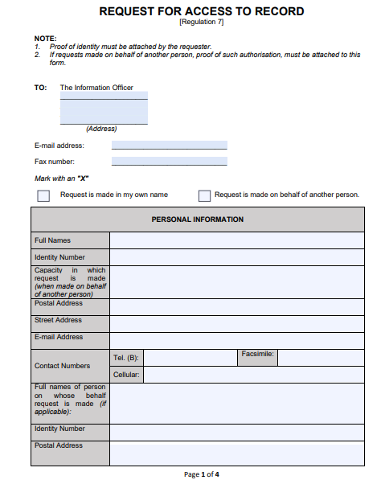

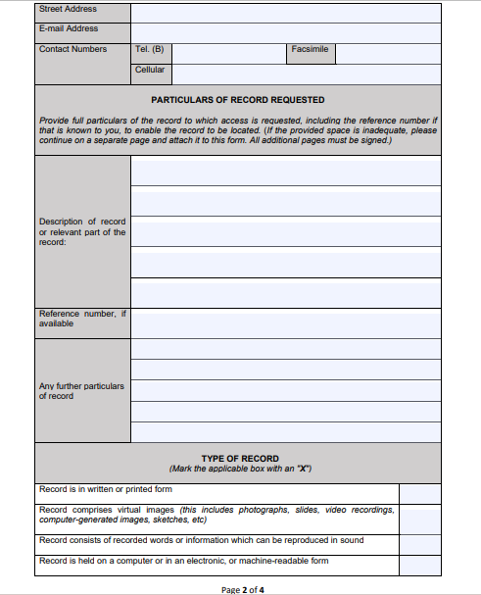

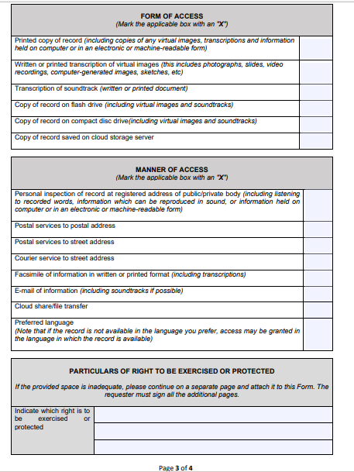

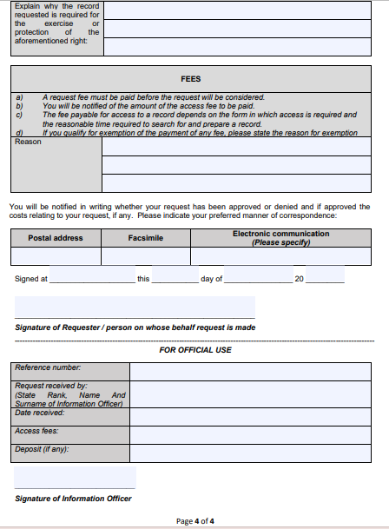

ADDENDUM B: FORM 3
Also available from the SAHRC’s website at www.sahrc.org.za.

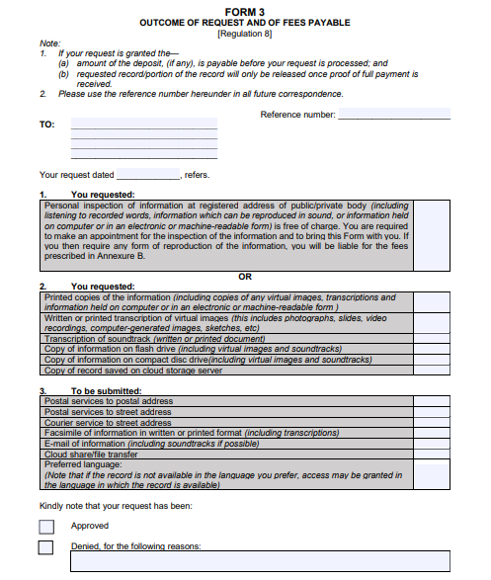

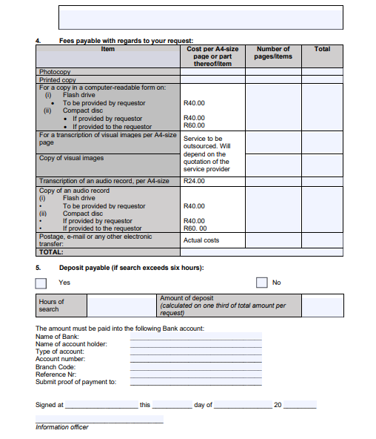

ADDENDUM C: FEES

Also available from the SAHRC’s website at www.sahrc.org.za.

      - REPRODUCTION FEES

Information in an A4 size page photocopy or part thereof | R1.10
A printed copy of an A4 size page or part thereof | R0.75
A copy in computer readable format –  Stiffy disk, Compact disk, USB flash-drive | R70.00
A transcription of visual images, in an A4 size page or part thereof | R40.00
A copy of a visual image | R60.00
A transcription of an audio record for an A4 size page or part thereof | R20.00
A copy of audio record | R30.00

      - ACCESS FEES

Information in an A4 size page photocopy or part thereof | R1.10
A printed copy of an A4 size page or part thereof | R0.75
A copy in computer readable format –  Stiffy disk, Compact disk, USB flash-drive | R70.00
A transcription of visual images, in an A4 size page or part thereof | R40.00
A copy of a visual image | R60.00
A search for a record that must be disclosed:  **** per hour or part of an hour reasonable required for such search | R30.00
A copy of audio record | R30.00

      - BANK ACCOUNT DETAILS FOR PURPOSES OF PAYMENT/S:

ACCOUNT NAME
BANKING INSTITUTION
ACCOUNT NUMBER
BANK BRANCH
PAYMENT REFERENCE

